Rishi Sharma

IT 520

9/24/18

1. What is the TCP port number used by your computer to communicate with gaia.cs.umass.edu?

Source Port: 64193

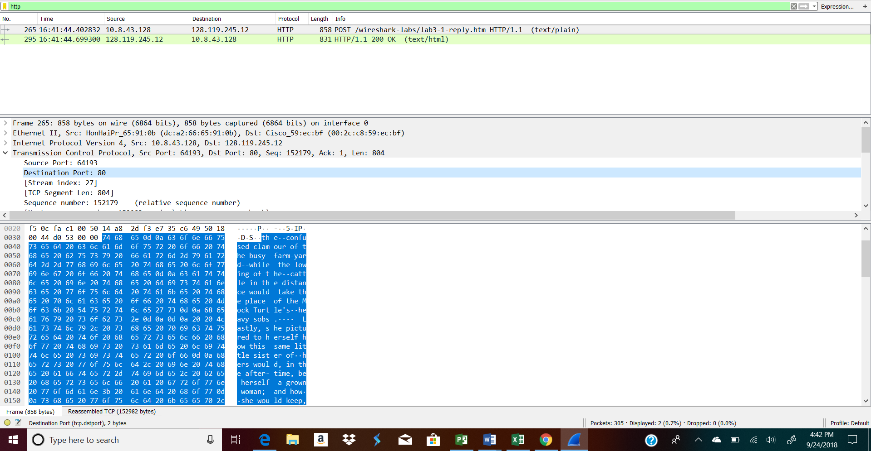

1. What is the TCP port number used by gaia.cs.umass.edu to communicate with your computer?

TCP Port #: 80

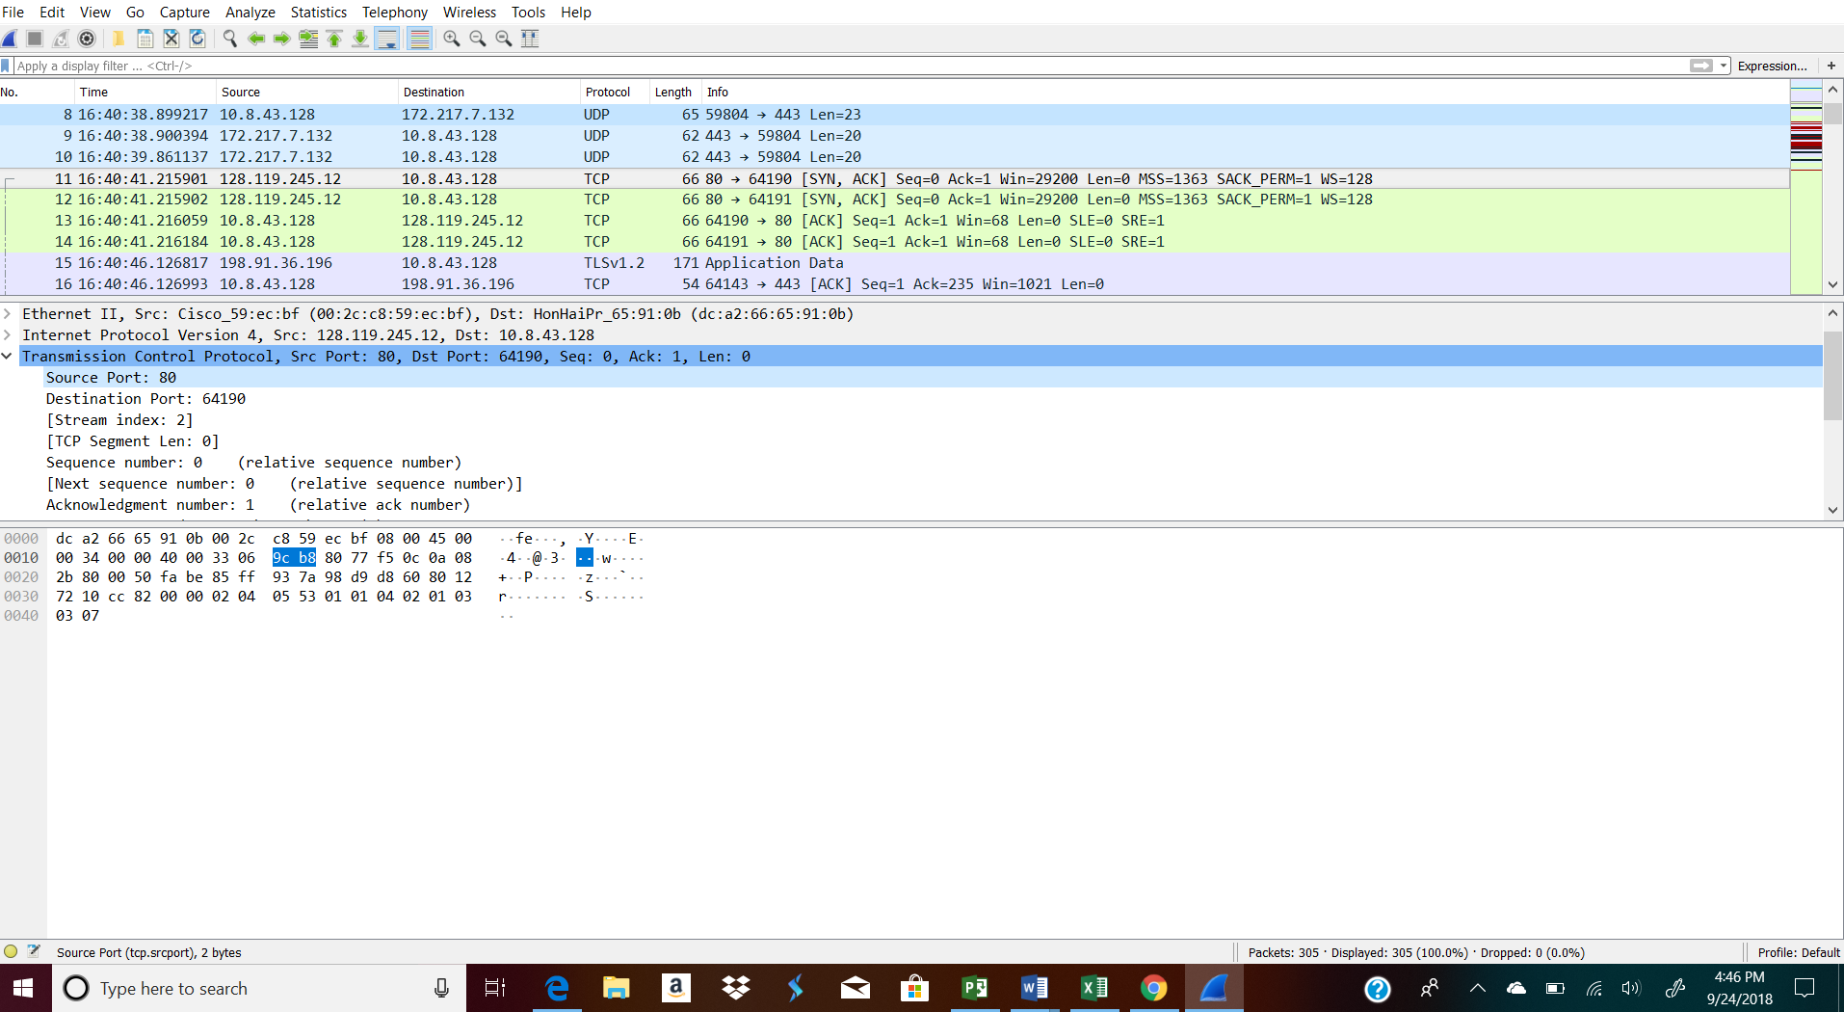

1. What is the sequence number of the TCP SYN segment that is used to initiate the TCP connection between your computer and gaia.cs.umass.edu? What is it in the segment that identifies the segment as a SYN segment?

Sequence Number: 0 and the 1 highlighted indicates that it is the Syn segment

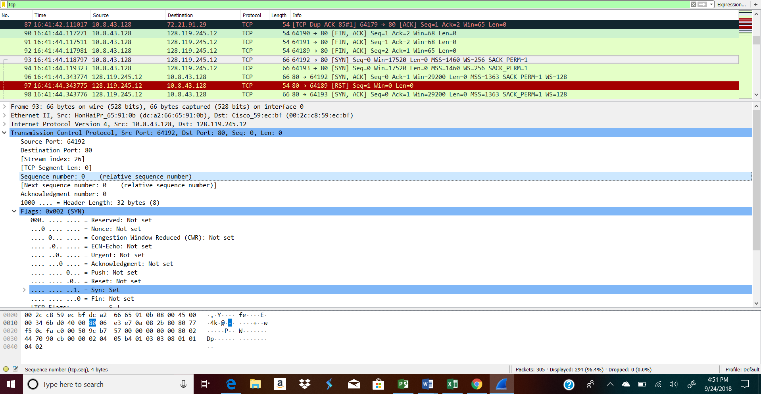

1. What is the sequence number of the SYNACK segment sent by gaia.cs.umass.edu to the client computer in reply to the SYN? - You must dig deep and find the ACK from gaia.cs.umass.edu.

Sequence #: 0

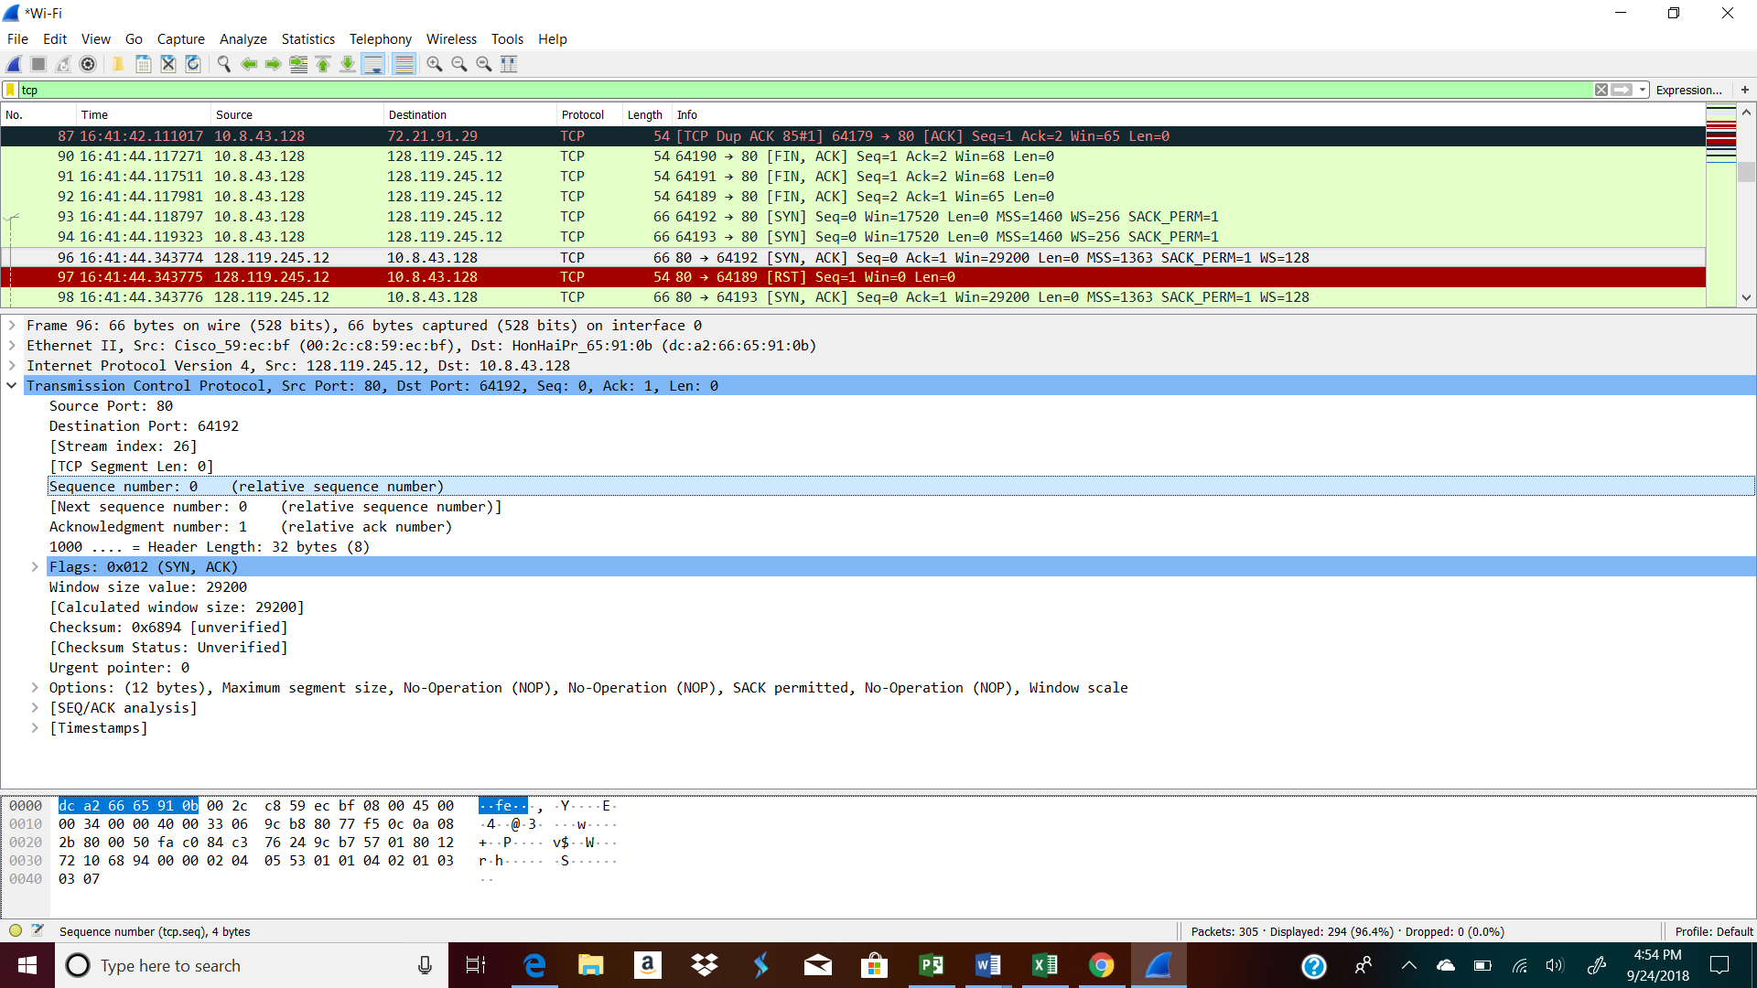

1. What is the sequence number of the TCP segment containing the HTTP POST command? Note: that to find the POST command, you’ll need to dig into the packet content field at the bottom of the Wireshark window, looking for a segment with a “POST” within its DATA field.

Sequence number: 152179

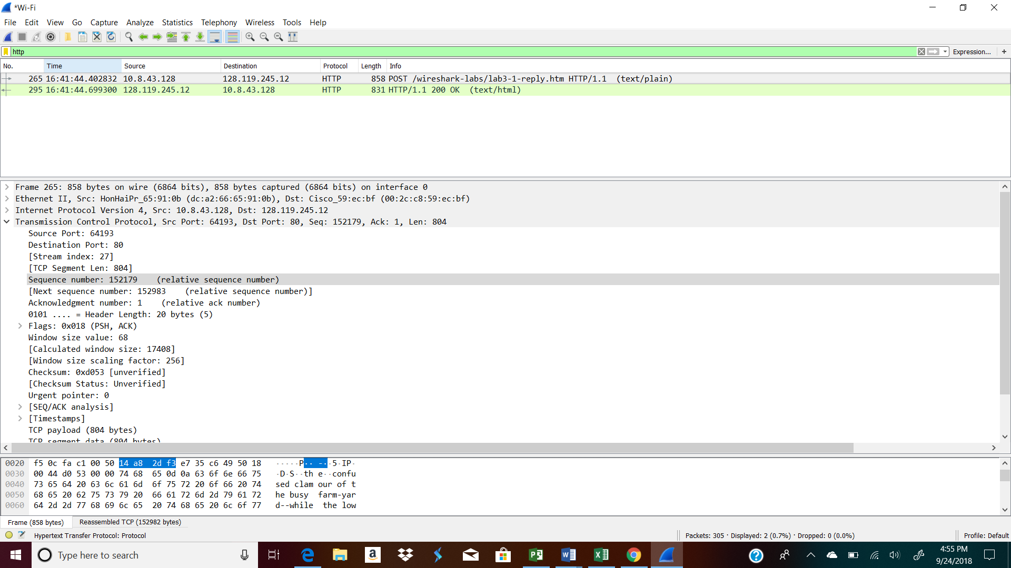

Ok Message:

Frame 295: 831 bytes on wire (6648 bits), 831 bytes captured (6648 bits) on interface 0 Ethernet II, Src: Cisco_59:ec:bf (00:2c:c8:59:ec:bf), Dst: HonHaiPr_65:91:0b (dc:a2:66:65:91:0b) Internet Protocol Version 4, Src: 128.119.245.12, Dst: 10.8.43.128 Transmission Control Protocol, Src Port: 80, Dst Port: 64193, Seq: 1, Ack: 152983, Len: 777 Source Port: 80 Destination Port: 64193 [Stream index: 27] [TCP Segment Len: 777] Sequence number: 1 (relative sequence number) [Next sequence number: 778 (relative sequence number)] Acknowledgment number: 152983 (relative ack number) 0101 .... = Header Length: 20 bytes (5) Flags: 0x018 (PSH, ACK) Window size value: 1432 [Calculated window size: 183296] [Window size scaling factor: 128] Checksum: 0x7c88 [unverified] [Checksum Status: Unverified] Urgent pointer: 0 [SEQ/ACK analysis] [Timestamps] TCP payload (777 bytes) Hypertext Transfer Protocol Line-based text data: text/html (11 lines)

